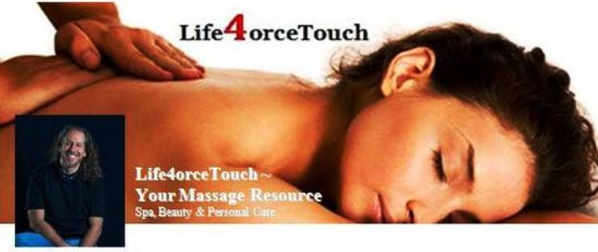

The Power of Touch

In A High-Tech World, It Pays to Reach Out
By Nora Brunner

Originally published in Body Sense, Autumn/Winter 2009. Copyright 2009. Associated Bodywork and Massage Professionals. All rights reserved.

Physician and holistic health pioneer Rachel Naomi Remen once confessed that as a pediatric intern she was an unrepentant baby kisser, often smooching her little patients as she made her rounds at the hospital. She did this when no one was looking because she sensed her colleagues would frown on her behavior, even though she couldn't think of a single reason not to do it.

The lack of basic human contact in our high-tech medical system reflects a larger social ill that has only recently started to get some attention--touch deprivation. The cultural landscape is puzzling. On the one hand, we are saturated in suggestive messages by the mass media; on the other hand, the caring pediatrician is afraid someone might look askance at her planting a kiss on a baby's forehead. What's wrong with this picture?

Social Norms

Unfortunately, touch has become, well, a touchy subject. Though there's growing scientific evidence that skin-to-skin contact is beneficial to human health, American social norms inhibit this most basic form of human interaction and communication. Despite our supposedly enlightened attitudes, we Americans are among the most touch-deprived people in the world.

"Touch deprivation is a reality in American culture as a whole," writes Reverend Anthony David of Atlanta. "It's just not babies needing to be touched in caring ways, or the sick. It's not just doctors and nurses needing to extend it. It's all of us, needing connection, needing to receive it, needing to give it, with genuine happiness at stake." | 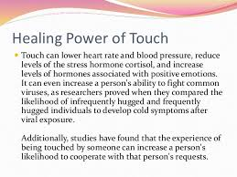

Distant and Disconnected

How did we come to deprive ourselves so tragically? According to Texas psychology professor David R. Cross, PhD, there are three reasons Americans don't touch each other more: fear of sexual innuendo, societal and personal disconnection aided by technology, and the fact that the ill effects of non-touching are simply not that obvious and don't receive much attention.

It's no surprise we Americans are often afraid physical touching signals romantic interest, which leads to the twin perils of either having our intentions misunderstood or wondering if someone's gesture is an uninvited advance. This ambiguity is more than enough to scare most people from taking someone's arm or patting them on the back.

The potential for the loaded gesture is further complicated by our litigious society in which unwelcome touch can mean, or be interpreted as, dominance, sexual harassment, or exploitation. People in the helping professions are regularly counseled on how to do their jobs without creating even a hint of ambiguity. In one extreme example, counselors at a children's summer camp were given the advice that when kids proactively hugged them, the counselors were to raise both arms over their heads to show they hadn't invited the contact and weren't participating in it. One wonders how the innocent minds of children will interpret this bizarre response to their spontaneous affection.

Another reason for touch phobia, according to Cross, is that we live in an avoidant society with far-flung families and declining community connections. Technology plays a significant role in the way we communicate, and it seems we move farther away from face-to-face human communication with every new invention. How ironic that the old telephone company jingle that encouraged us to "Reach Out and Touch Someone" gave way to the slew of electronic devices we have today, all ringing, singing, and beeping for our attention. While these devices were invented to improve communication, some people wonder if the net effect is lower quality in our exchanges of information.

Cross says the negative effects of non-touch aren't obvious. While there is scientific research showing non-touch is detrimental to health, none of these effects grab headlines, sound alarms, or elicit urgent concern. The effects are more insidious and long-term and don't amount to a dramatic story for prime time.  "Humans deprived of touch are prone to mental illness, violence, compromised immune systems, and poor self-regulation," Cross says. So serious are the effects of touch deprivation, it's considered by researchers to be worse than physical abuse. | 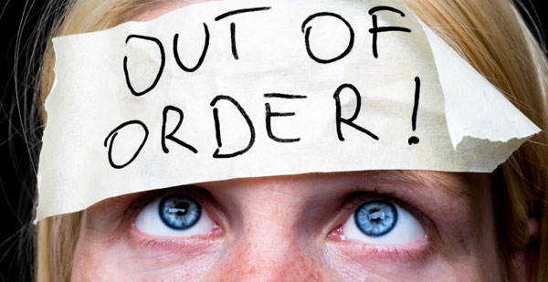

Benefits of Touch

Stated more positively, science does support the preventive health benefits of touch. For example, infant massage has gained popularity as studies have shown pre-term babies receiving massage gain more weight and are healthier than non-massaged preemies. Experiments with baby monkeys showed they preferred mother surrogates, like terry cloth dummies, to food.

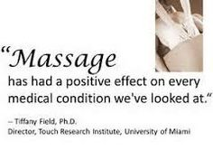 | Tiffany Field, PhD, founder of the Touch Research Institute, notes that in a study on pre-term infants, massaging the babies increased their weight and allowed them to be discharged earlier. Discharging babies earlier from expensive neonatal intensive care units could save the healthcare system $4.7 billion annually.
In other research, scientists at the University of North Carolina found the stress hormone, cortisol, was reduced with hugging. Cortisol is associated with anger, anxiety, physical tension, and weakened immunity. They also discovered hugging led to positive physiological and emotional changes in the body, noting that a mere 20 seconds of hugging boosted levels of the hormone oxytocin, which improved heart function.

Touch Quotient

Massage therapy has been found useful in reducing symptoms such as anxiety, depression, pain, and stress in conjunction with various illnesses and treatments, including anorexia nervosa, arthritis, cancer, fibromyalgia, muscular pain and stiffness, strokes, and postsurgery care.

While more research is needed, massage therapy has also been shown to reduce symptoms associated with alcohol withdrawal and smoking cessation, and can improve self-esteem, boost the immune system, increase flexibility, and improve sleep.

You might think with all the problems in our expensive, symptom-driven American healthcare system, we'd take every opportunity to afford ourselves health-promoting activities that are far more pleasant than sweating it out at the gym. Yet, we are still finding our way in terms of increasing our touch quotient. | 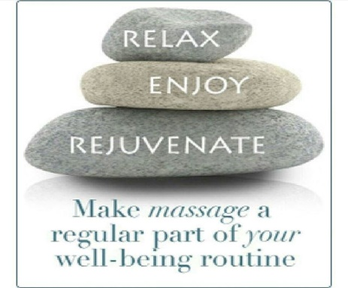

Perhaps one of the fathers of the modern massage movement, the late Robert Noah Calvert, said it best: "The application of caring human touch is an inherently innate behavior for giving and receiving love, which all humankind wants and needs. The real purpose of giving massage is to foster more depth of feeling for one another in order to bring out the love that often lies buried beneath the pain of everyday suffering."

The patients of that baby-kissing pediatrician were lucky. They'll never know how fortunate they were to receive such basic and unadorned human care as they entered a fast-paced, technologically advanced world.

Schedule Your Touch Time Today by Calling or On-line at:

MassageTherapyinPhiladelphiapa.com

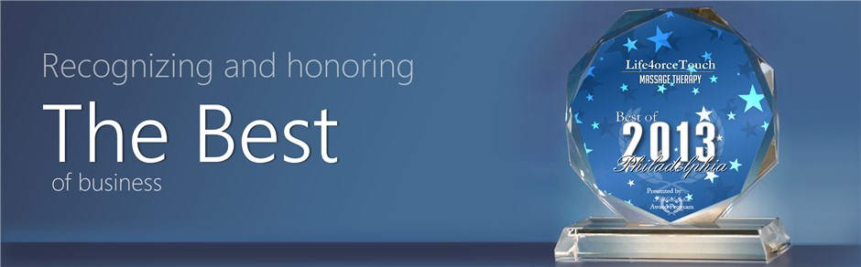 | 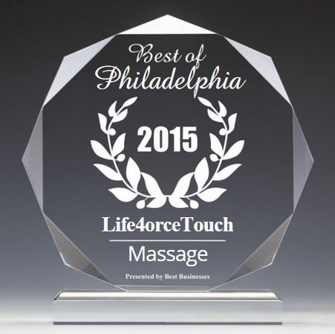 | 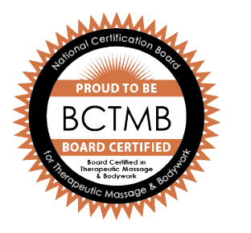

Frank
(267) 253-0197
Life4orceTouch
Your Massage Resource
Awarded 2015/2013 Best in Philly – For A Good Reason

